Transfer function synthesis and stability
Q1) The transfer functions were synthesized and pole zero plots were produced as verification.
Q2) The impulse response was plotted as well.
Q3) Beside each figure the stability is commented upon.
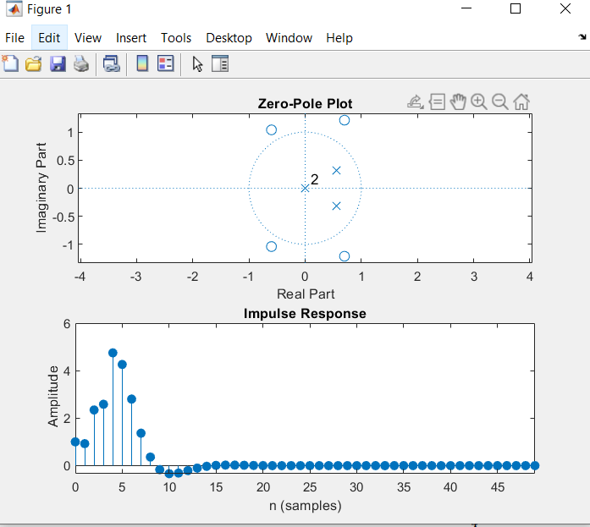 | Based on the impulse it is clearly stable as it decays to zero
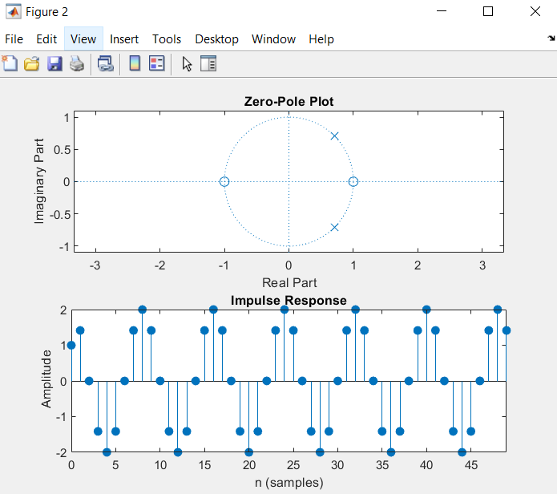 | Based on the pole zero plot, all poles are on the left side, no multiple poles on jw axis and degree of numerator is less then 1 greater than of the denominator. Because of all these reasons the system has some type of stability. However, based on the impulse response it is only marginally stable because it does not decay to zero.
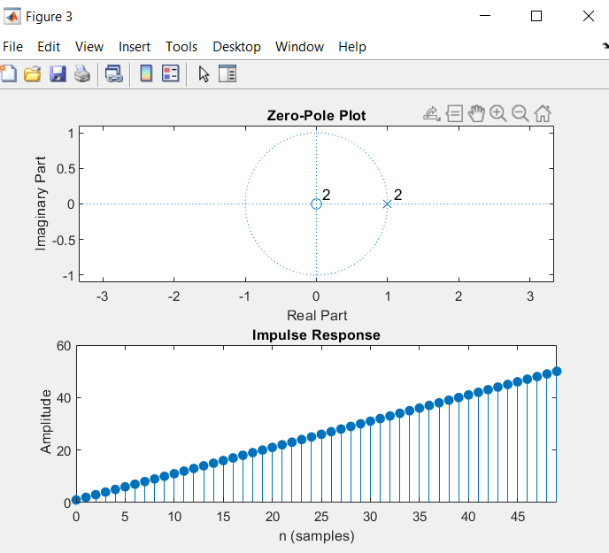 | Based on the impulse response this is clearly unstable as it grows unboundedly towards infinity.

Pole-zero, magnitude, and phase response plots
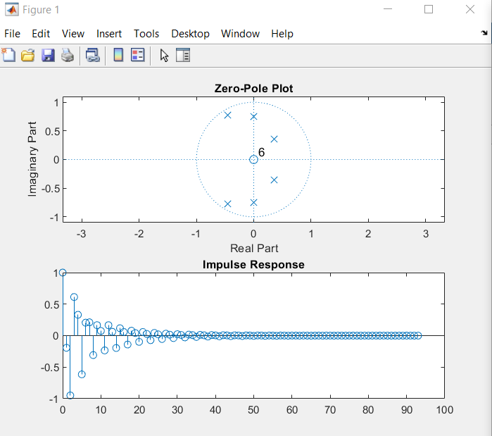 | Q1) Based on this pole zero plot, the system is stable and resembles the plot of a band pass filter.  Q2) The system seems stable because all poles are within unit circle. Impulse response decays to zero which is confirmation.
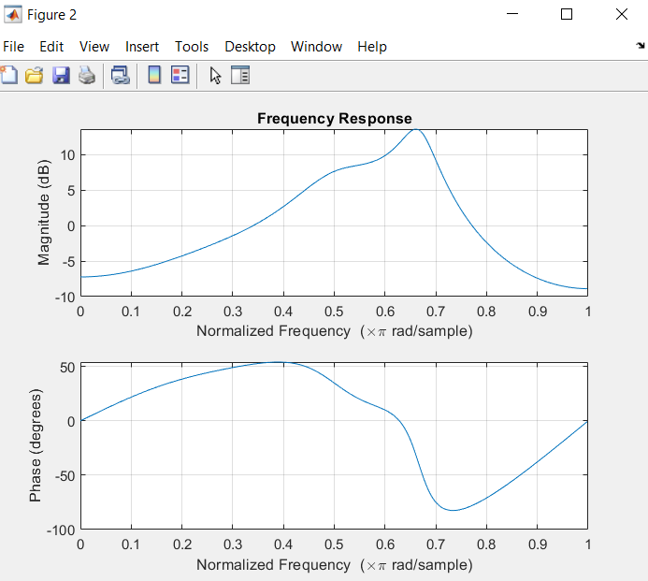 | Q3) Yes, this as expected. The magnitude shown on this graph is clearly a band pass filter.

Notch filter design & implementation
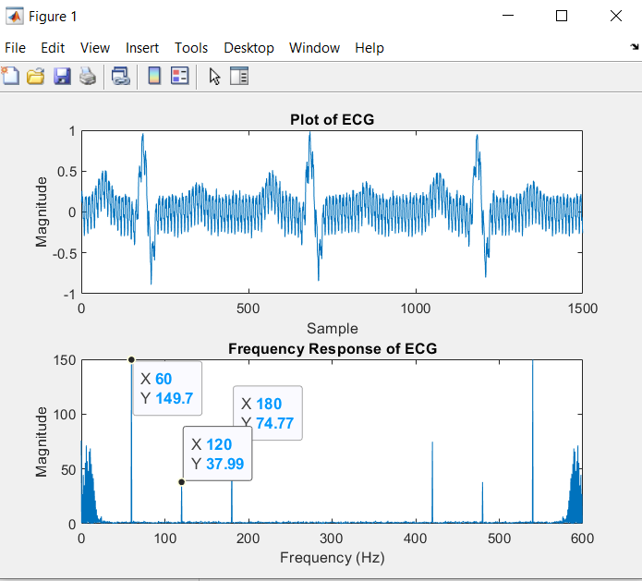 | Q1) Using spectral analysis we can see that the interference components are 60 Hz, 120 Hz &180 Hz. This is from the power line which is 60 Hz and all of its aliasing components.
 | Q2) shown in code
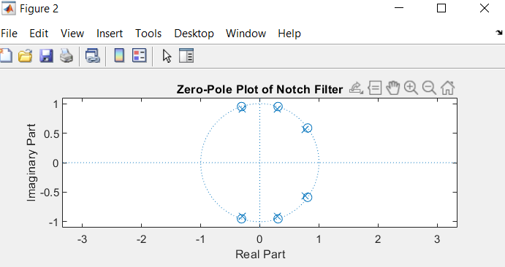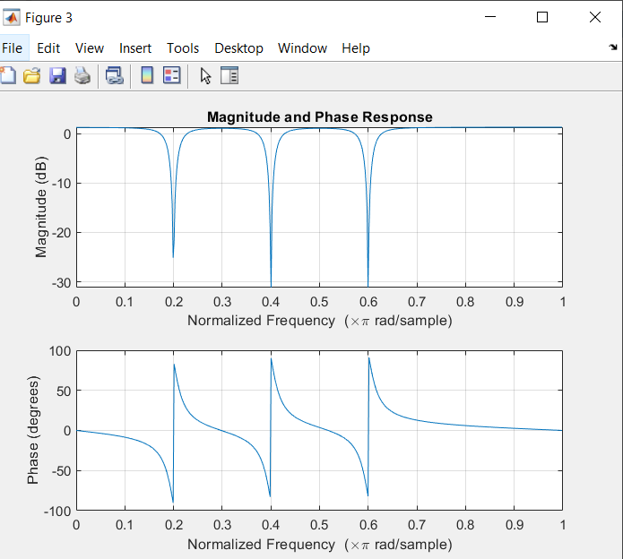 | Q3) show zero pole plot and magnitude and phase response plots. We can see the notch filter is filtering out the exact frequencies that we want to remove (in radians, so convert to HZ).
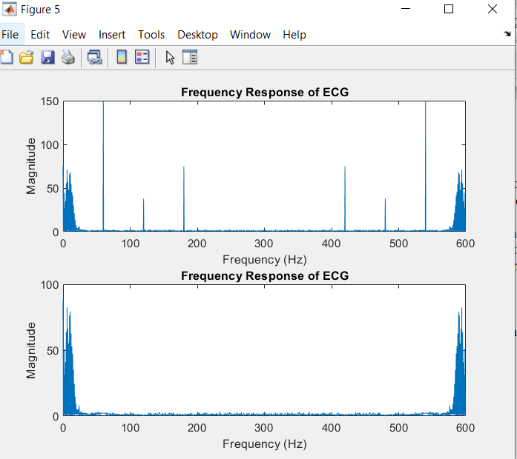  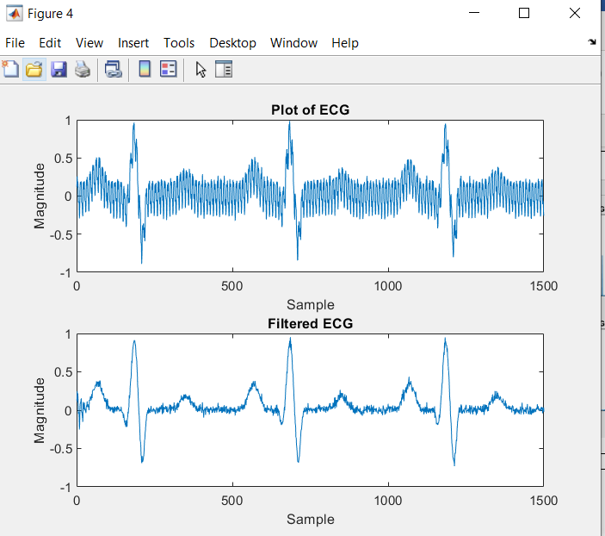 | Q4) The notch filter removed all interference components successfully, providing a clean signal to work with.

